# Assessment Task

# Applied Information Technology – ATAR Year 12

## Task 5 – Unit 3 – Project: Create a prototype online store

**Assessment type:** Project

**Conditions**

Time for the task: Four weeks

**Task weighting**

15% of the school mark for this pair of units

__________________________________________________________________________________

This task requires you to create a prototype website for an online store.

The material that needs to be submitted for this task includes:

* A document that details.
* The finished product in your school network drive.

Follow the steps below to complete this task:

**Define and analyse problem**

* Identify the name of the customer and the type of store
* Research similar existing sites, provide URLs and screenshots
* Identify useful design features from those websites
* Identify three design criteria that can be used to evaluate the finished product.

**Design Solution**

* Find a CSS template that meets all your customer’s requirements as much as possible.
* Annotate a screenshot of the template to explain how the design satisfies your requirements.

**Build Prototype**

* Download the CSS template.
* Extract the template to an appropriately named folder.
* Set up pages and navigation so that the basic framework of the website is functional.
* Start and maintain a daily journal of the production process.
* Add or remove pages and navigation features as necessary.
* Add content such as text and media to the website.

**Evaluate Solution**

* Use the design criteria you developed earlier to assess your finished product.
* Describe the best aspect of the website.
* Describe the aspect of the website that you are least satisfied with.
* Explain any difficulties you encountered and how you overcame them.

**CSS Templates**

Free CSS templates for online shops can be found at the following websites:

<http://www.free-css.com/template-categories/online-shop>

<http://www.dreamtemplate.com/templates/shopping-website-templates.html>

<http://www.beautifullife.info/web-design/25-best-free-online-stores-templates/>

There are plenty of other websites out there to be found as well.

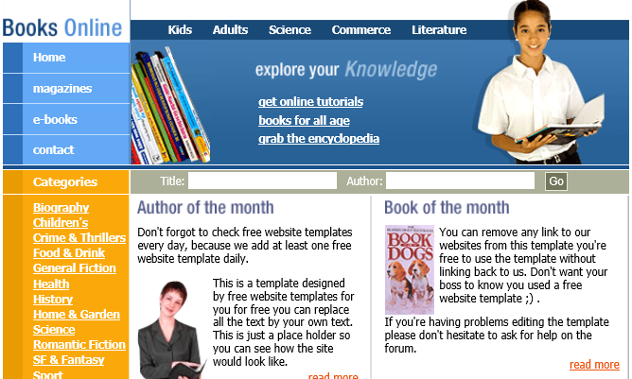

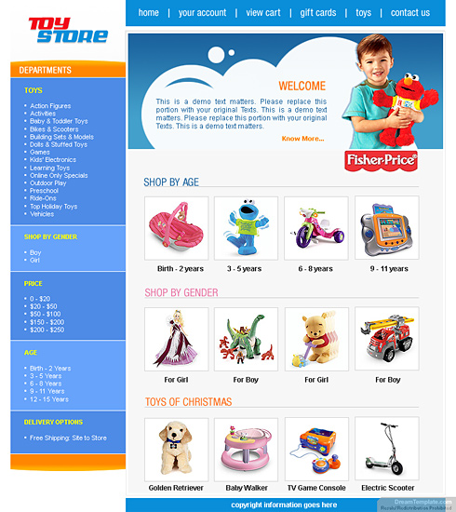

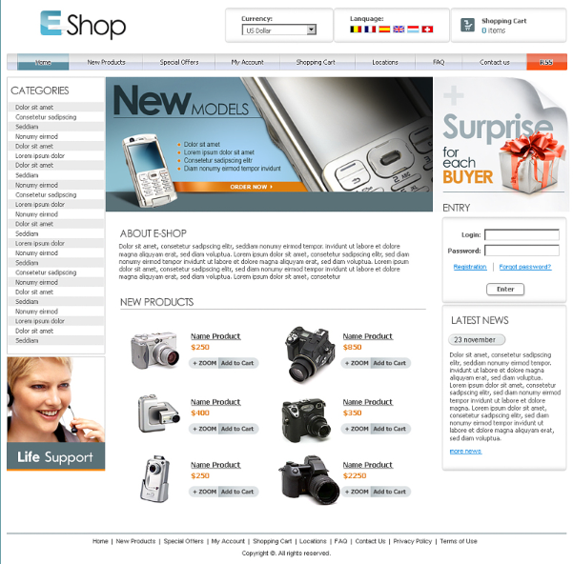

# Marking key for Assessment Task 5 — Unit 3 – **Prototype online store**

|  |  |  |
| --- | --- | --- |
| **Description** | **Possible Marks** | **Your marks** |
| **Define and analyse problem** | |  |
| * Identify the name of the customer and the type of store * Research similar existing sites, provide URLs and screenshots * Identify useful design features from those websites * Identify three design criteria that can be used to evaluate the finished product. | 2  4  4  3 |  |
| **Define total** | **13** |  |
| **Design Solution** | |  |
| * Find a CSS template that meets all your customer’s requirements as much as possible. * Annotate a screenshot of the template to explain how the design satisfies your requirements. | 3  5 |  |
| **Design total** | **8** |  |
| **Build Prototype** | |  |
| * Download the CSS template. * Extract the template to an appropriately named folder. * Set up pages and navigation so that the basic framework of the website is functional. * Start and maintain a daily journal of the production process. * Add content such as text and media to the website. | 2  2  4  6  4 |  |
| **Production total** | **18** |  |
| **Evaluate Solution** | |  |
| * Use the design criteria you developed earlier to assess your finished product. * Describe the best aspect of the website. * Describe the aspect of the website that you are least satisfied with. * Explain any difficulties you encountered and how you overcame them. | 6  2  2  3 |  |
| **Evaluation total** | **13** |  |
| **Total** | **52** |  |